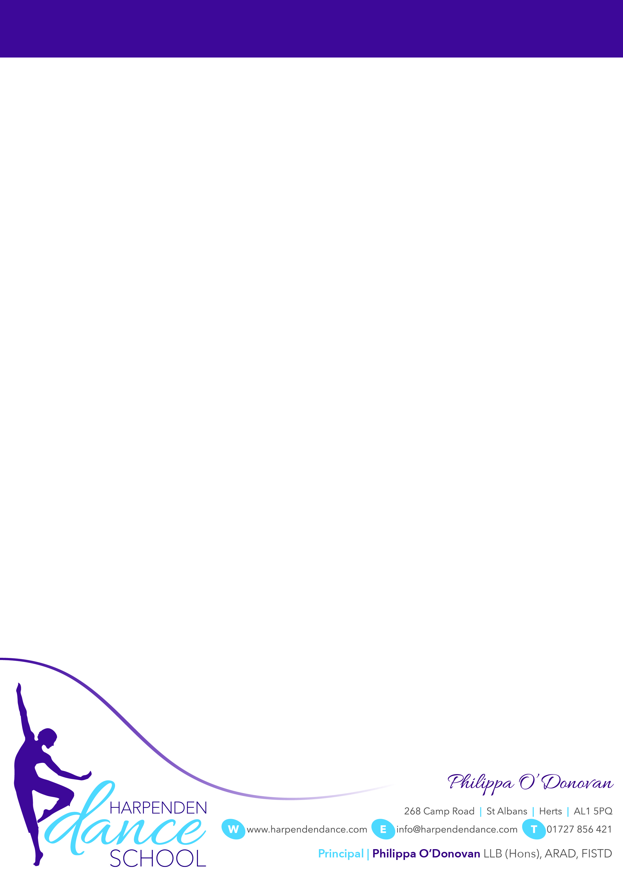

Dear Parents & Pupils

As we head towards the end of term, and before December fills our time with holiday excitement and preparation, we wanted to share our final newsletter of 2021.

**HDS Show - March 2022**

For pupils in Grade 1 and above* who are aged 6 years and above, you should now all have received an email giving dates and details of our show next term. Please remember to complete and submit the Permission Form if you haven't yet done so. If you haven't received any information or a link to the form, please get in touch ASAP!

**Watching Week**

Please note that for those classes taking part in the show (so Grade 1 and above*) there will be **NO** Watching Week this term as work has already begun on the show choreography!

For those who attend Pre-School Dance, Pre-Primary Ballet, Theatre Dance, and Friday Primary Ballet, Watching Week will be held during the final week of term from **6th-10th December 2021.**  Those who attend Inter Foundation Ballet will also be included in Watching Week.

In the interests of keeping things as Covid-secure as we can, may we please ask that numbers of watchers are kept to a minimum for each dancer and that audience members wear a mask throughout. Please also note that it may be chilly in class as we will keep our venues fully ventilated.

* Miss O’Donovan’s Wednesday class are the exception to this and will be included in the show as the age requirement is largely met in this class and without Covid disturbances this class would have progressed to being a Grade 1 class in time for the show.

**Uniform**

A reminder please that all dancers should attend class in the appropriate HDS uniform (with extra layers as required by the weather).  We are aware there have been some stock and availability issues this term, but please remember that uniform items could make excellent Christmas gifts!

For dancers attending classes below Grade 6 level, please do **NOT** buy ballet shoes that feature a double elastic and/or a split sole. These are not suitable for dance training at this level.

**Covid Reminder**

As infection rates remain a concern, may we please remind you all to maintain social distancing whenever possible.  If pupils or immediate family members have tested positive or have been in close contact with anyone who has tested positive, may we please ask you NOT to attend classes or show rehearsals until after appropriate isolation or a negative test result has been received.

**Exam Results**

We were fortunate to be able to host both RAD Ballet and ISTD Tap and Modern exams face to face this term and were delighted with the hard work our dancers put in and the excellent results they all achieved.  Congratulations!!

Finally, a heartfelt thank you to everyone for working so well this term, despite positive PCRs, isolations, darker evenings and the challenges of the autumn term with continued restrictions at our venues: myself and the team have enjoyed dancing with you!  We hope you and your families and loved ones have a wonderful time over the holidays - and we look forward to welcoming you back in the New Year full of energy and enthusiasm for the show-term ahead!

All best wishes

**Newsletter Autumn 2021**